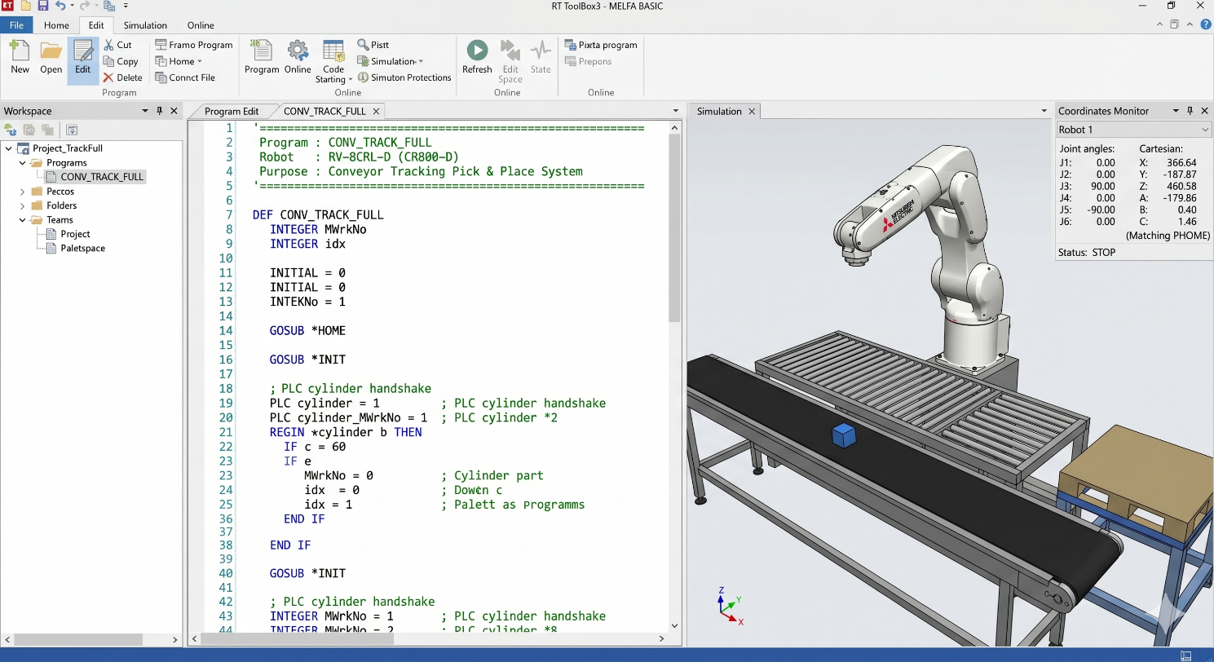
Figure 1: Program Initialization and Start of the 'CONV_TRACK_FULL' Loop.

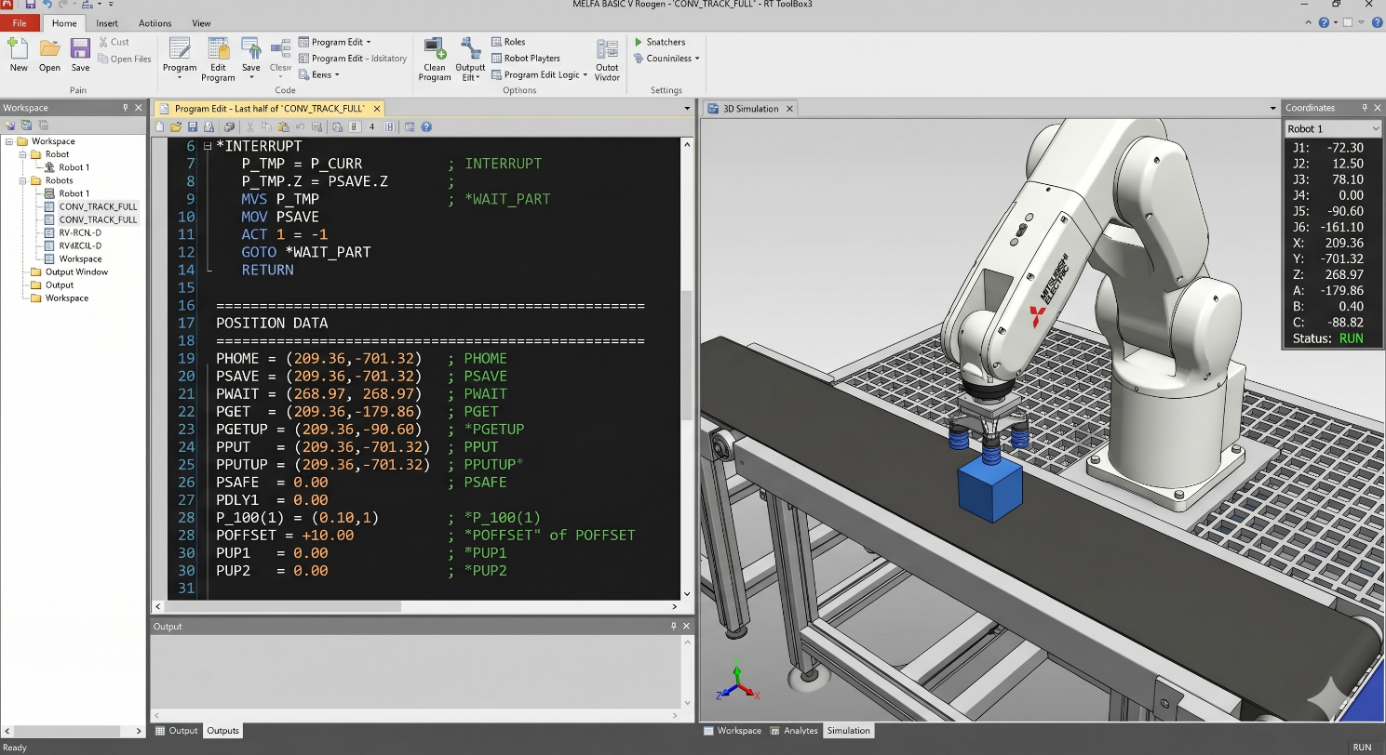
Figure 2: Complete Defined Position Coordinates and Variables Data Block.

Expt No:  06 | AUTONOMOUS MATERIAL HANDLING  AND MANIPULATION LOGIC
Date:
12 / 03 /2026

- AIM:
To design and implement an automated pick-and-place robotic sequence using asynchronous sensor handshaking, effector actuation, and precise spatial trajectory mapping on a 6-axis industrial manipulator.

- APPARATUS REQUIRED:
  - Robotic System: Mitsubishi RV-8CRL-D industrial manipulator.
  - Control Hardware: CR800-Series Controller.
  - Software Suite: RT ToolBox3 integrated engineering environment.
  - Sensing Hardware: Photoelectric workpiece detection sensor mapped to Input 6031.
  - Actuators: Component transport conveyor and pneumatic suction/gripper assembly actuated via Outputs 12/13.

- THEORY:
A fundamental robotic pick-and-place operation requires the seamless integration of spatial motion planning with digital logic control to interact with the external environment.
- Core Principle:
Autonomous manipulation relies on event-driven execution. The robot remains in a standby state until an external physical sensor triggers the initiation of a predefined sequence of kinematic sub-routines (retrieval, transfer, and placement).
- Working Mechanism:
  - Approach/Escape Kinematics: To prevent lateral sheer collisions with fixtures or components during retrieval and placement, the kinematic sequence strictly enforces relative Z-axis offsets (approach and escape heights). This ensures the tool only enters the manipulation zone vertically.
  - I/O Synchronization: The program architecture utilizes Wait M_In logic to halt motion execution until workpiece presence is verified by external instrumentation. Subsequent M_Out signals are triggered to electronically actuate pneumatic valves for payload securing and release.
  - Point-to-Point Transfer: The sequence utilizes a combination of joint interpolation (Mov) for rapid spatial repositioning and linear interpolation (Mvs) for the precise vertical insertion into the pick and place coordinates.

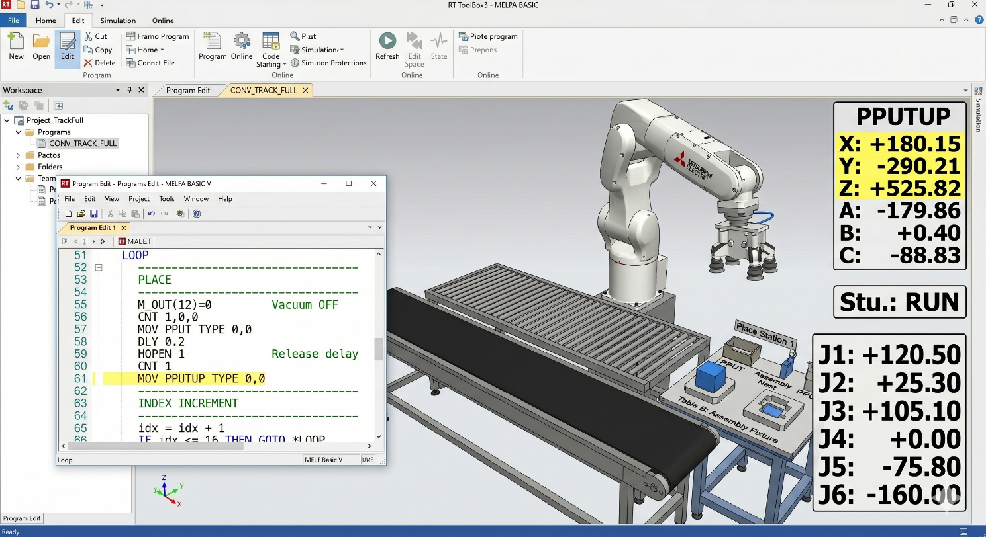
Figure 3: Maximized 3D Simulation Pane with Real-Time Coordinate Overlay at 'PGET' (Conveyor) Pick Station.

- PROCEDURE:
  - Setup & Connections:
Interface the photoelectric sensor and pneumatic solenoid valves with the controller's I/O terminals. Configure the conveyor system and define the absolute spatial coordinates for the "Pick" (pPick) and "Place" (pPlace) stations.
  - Algorithm & Logic:
    - Activate the component conveyor and enter a continuous monitor loop for workpiece arrival.
    - Upon photoelectric detection, halt the conveyor to stabilize the workpiece.
    - Execute the kinematic "Pick" sequence: move to a safe Z-offset above the part, perform a linear approach, engage the pneumatic effector, and execute a vertical escape.
    - Execute the "Place" sequence: move to a safe Z-offset above the drop zone, perform a linear insertion, disengage the pneumatic effector, and execute a vertical escape.
    - Reactivate the conveyor and loop the process for continuous automation.
  - Execution Steps:
    - Teach and record the absolute coordinates for pPick and pPlace using the teaching pendant.
    - Verify the "Hand Type" parameter in RT ToolBox3 matches the installed pneumatic assembly logic.
    - Validate the digital I/O handshake mechanism utilizing the Signal Monitor screen.
    - Execute a Step Run to ensure the Z-offsets safely clear all environmental obstacles before switching to Automatic mode for full-speed execution.
  - Observation Instructions:
Analyze the operational Tact Time (cycle time from pick to place) and monitor the pneumatic grip stability during rapid joint interpolation (Mov) between the pick and place stations.

- RESULT AND OBSERVATION:
The robotic system successfully performed synchronized pick-and-place operations with external conveyor and sensor systems. Proper approach/escape height control prevented interference, and reliable sensor handshaking ensured accurate part handling, as verified by faculty.

